Thursday, June 20, 2023

EX:1

HTML,HEAD,BODY TAG:

OUTPUT:

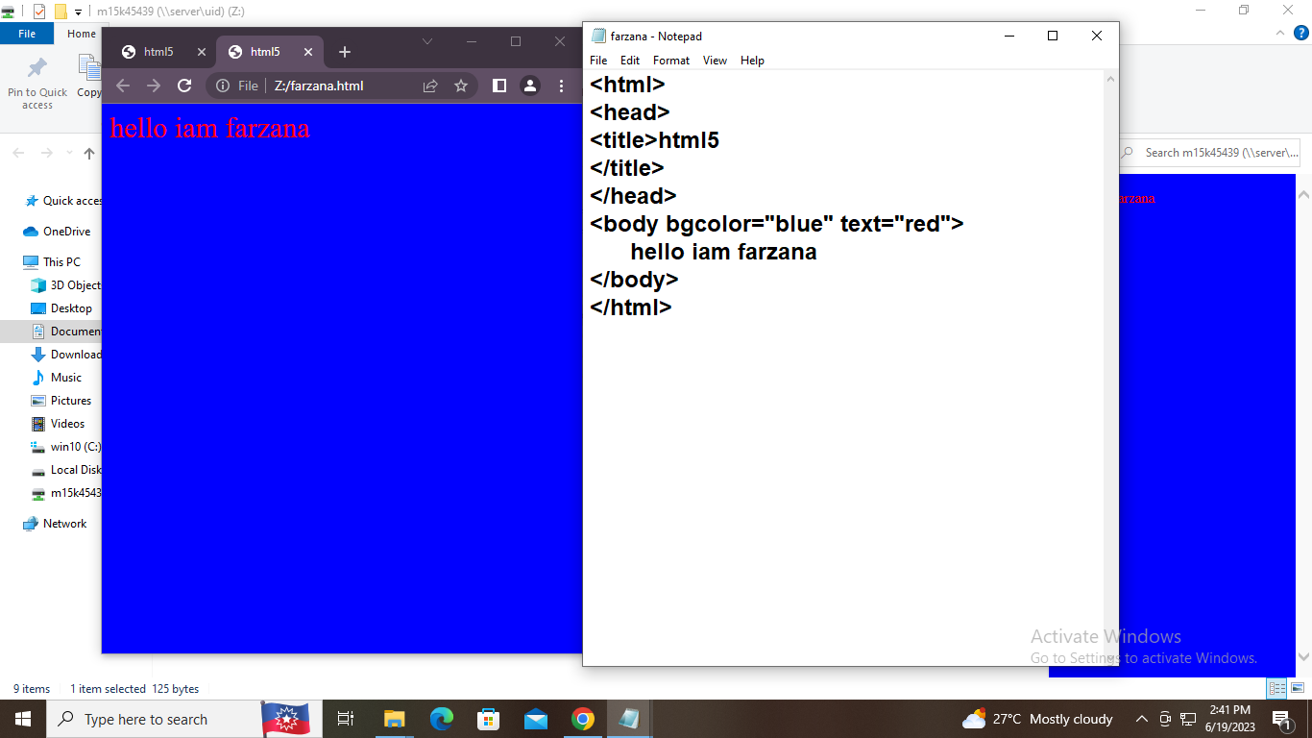

EX:2

HEADING TAGS:

OUTPUT:

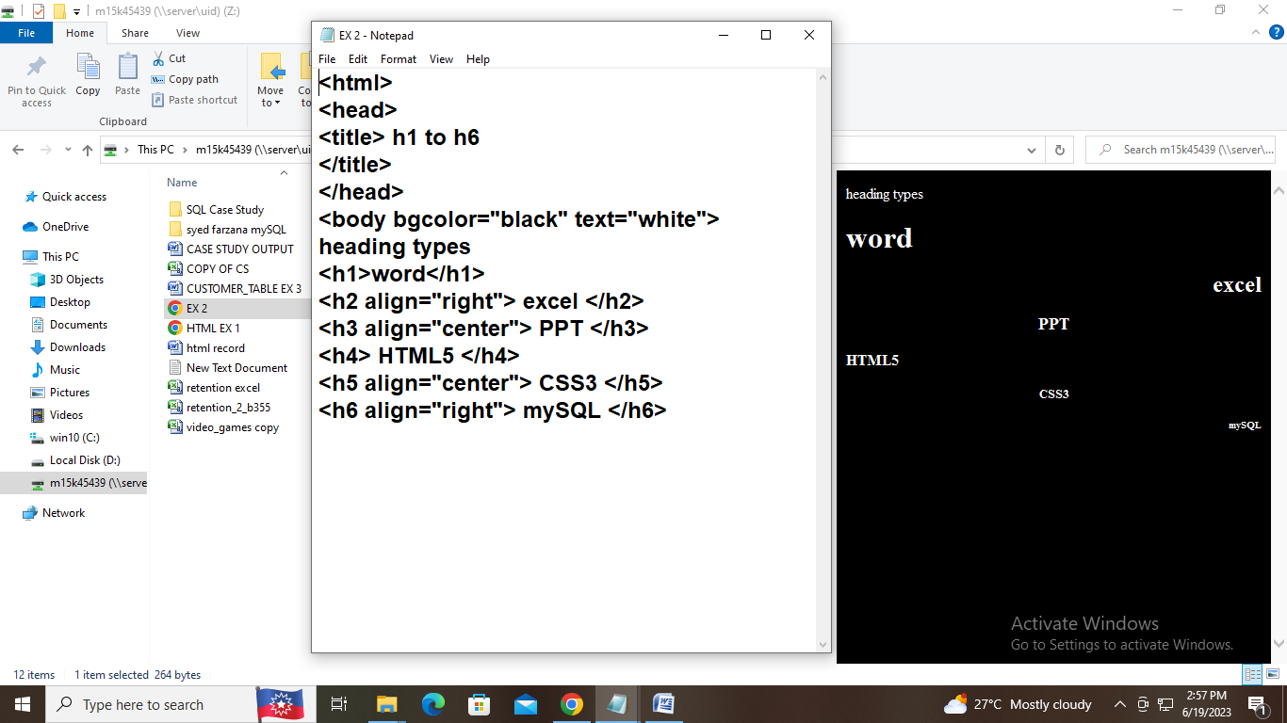

EX: 3

STYLE USING HTML5:

OUTPUT:

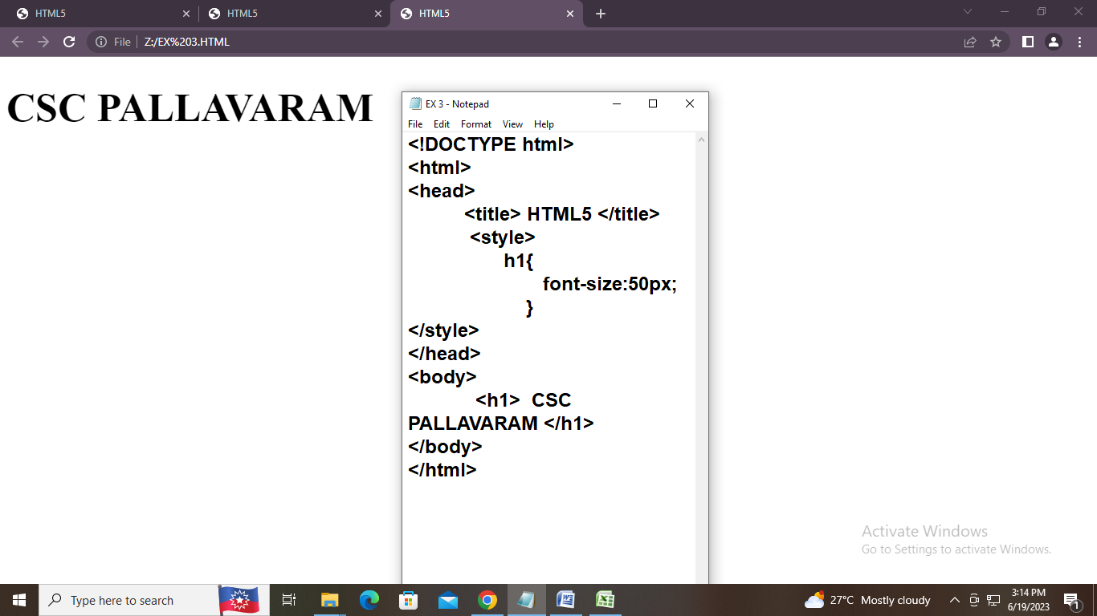

Ex 4:

DIV AND ASSIDE TAG:

Output:

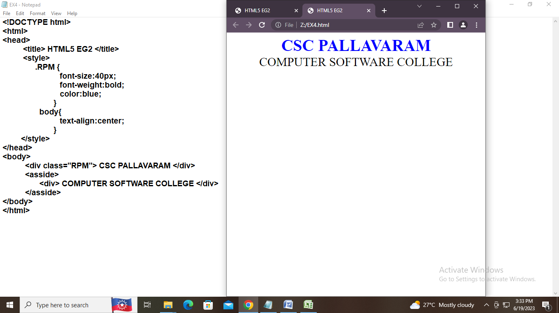

PROGRAM 1:

OUTPUT:

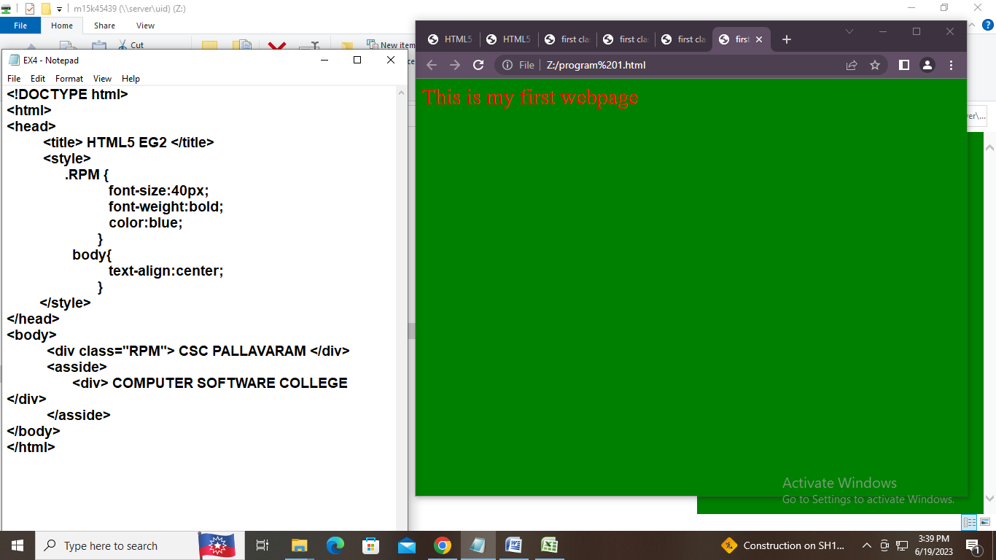

PROGRAM 2:

OUTPUT:

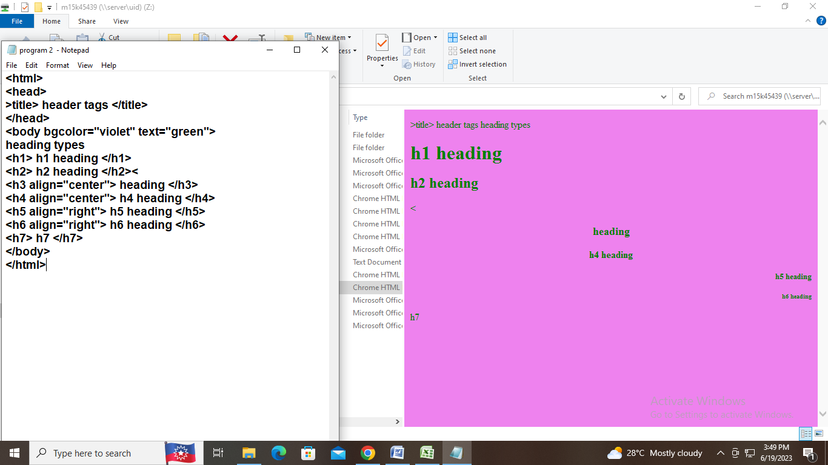

PROGRAM 3:

OUTPUT:

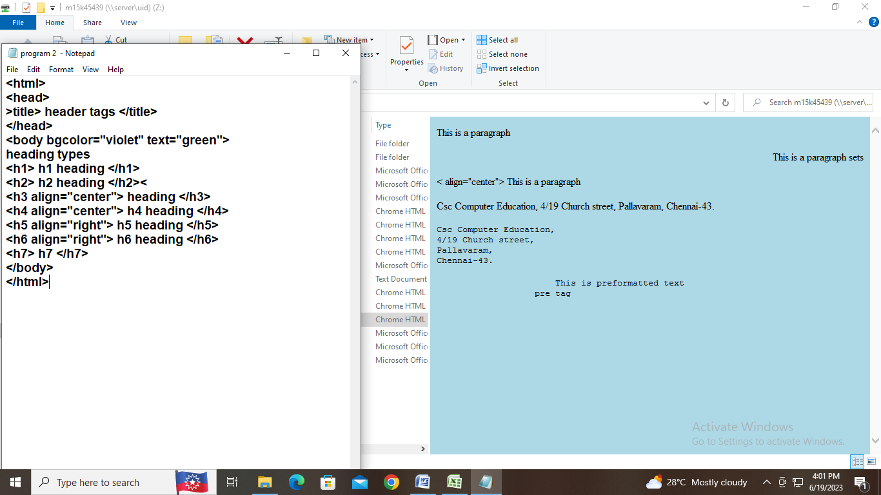

Thursday, June 21, 2023

EX: 5

IMAGE TAG:

OUTPUT:

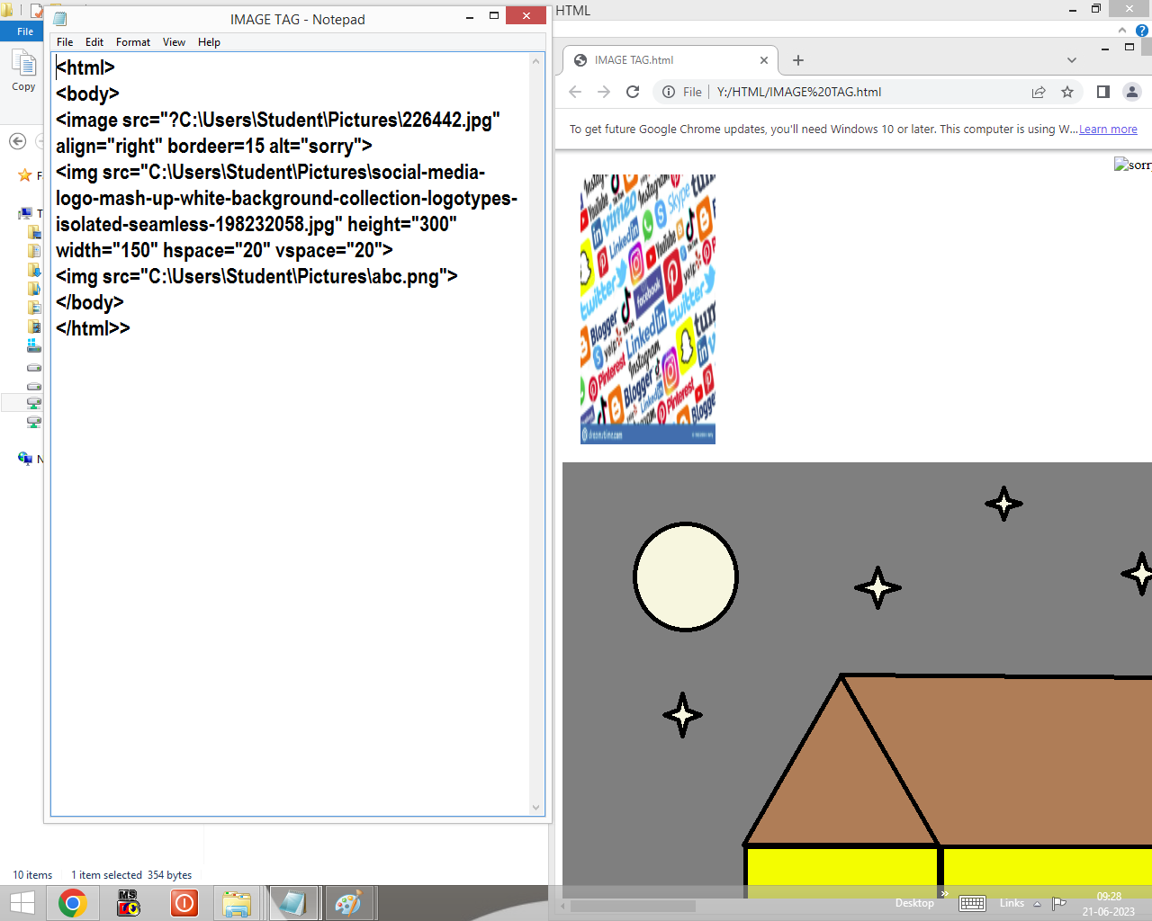

Thursday, June 22, 2023

EX: 6

LIST TAG:

OUTPUT:

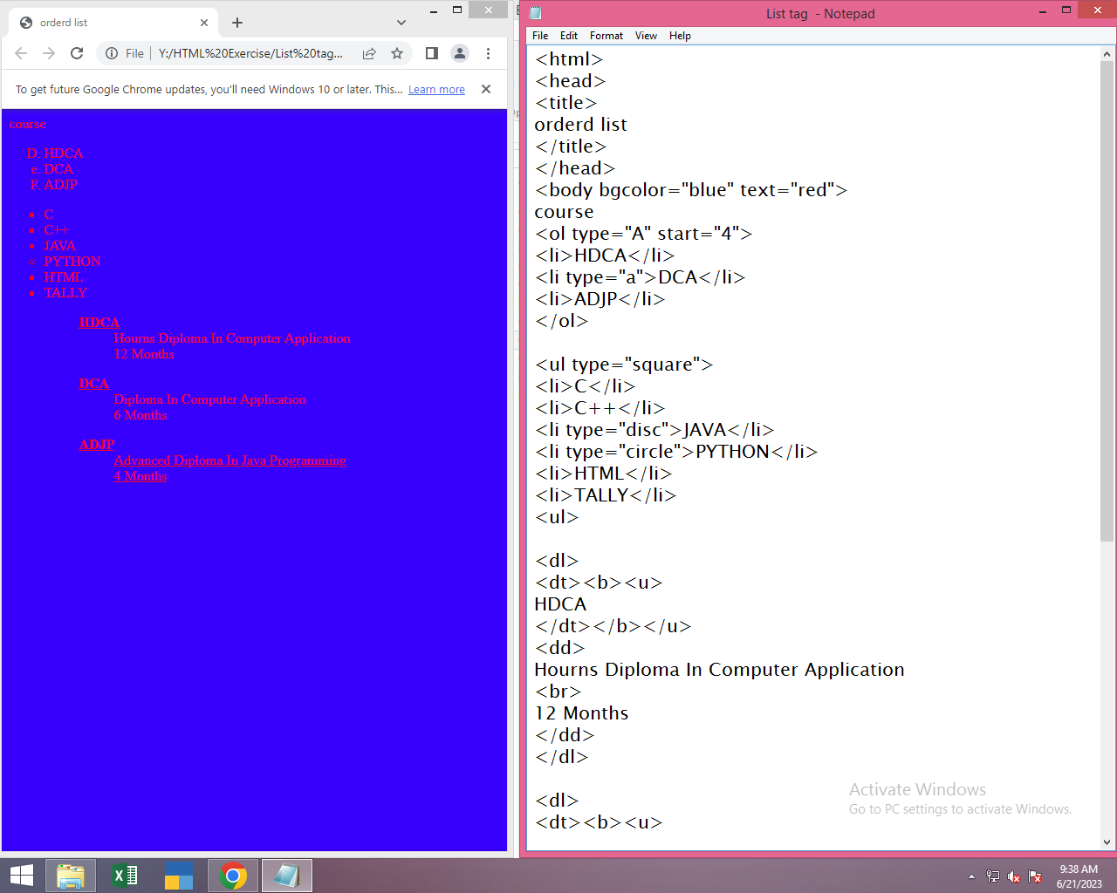

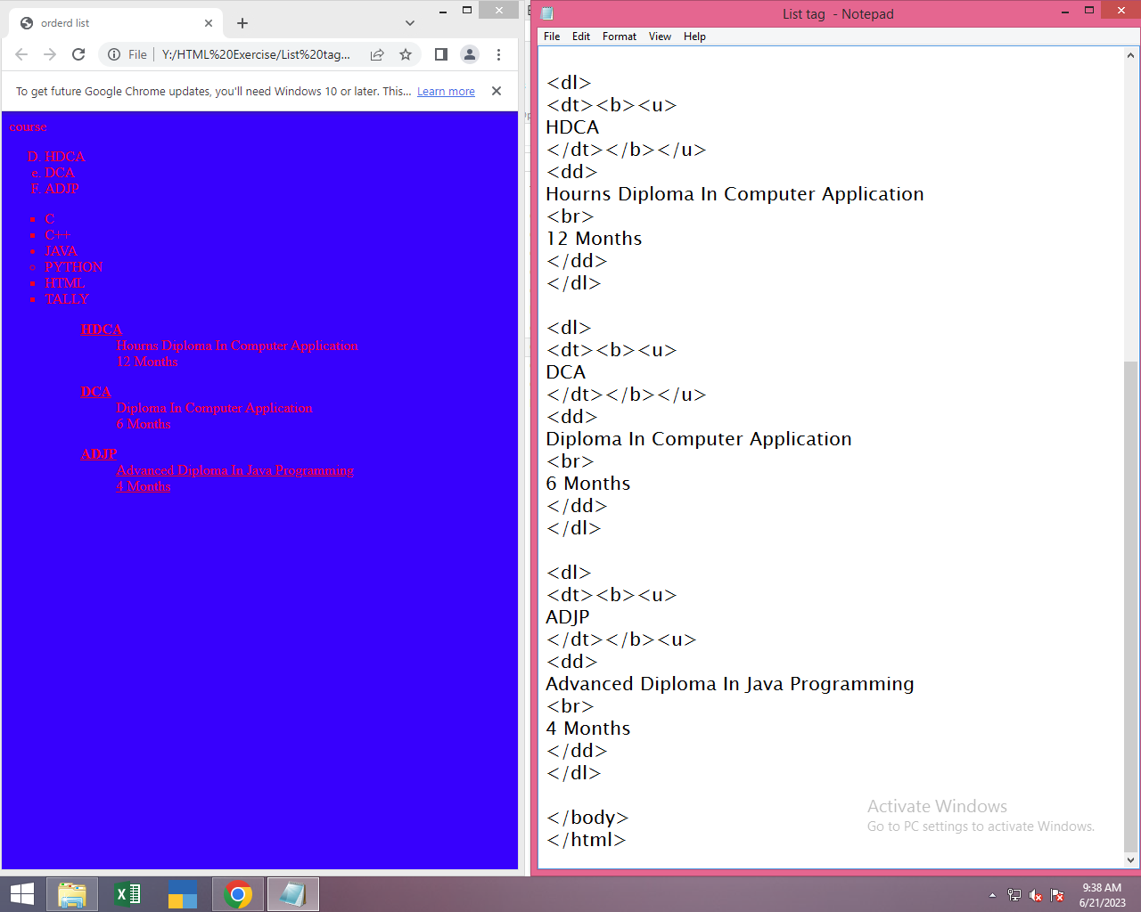

EX: 7

ANCHOR TAG:

OUTPUT:

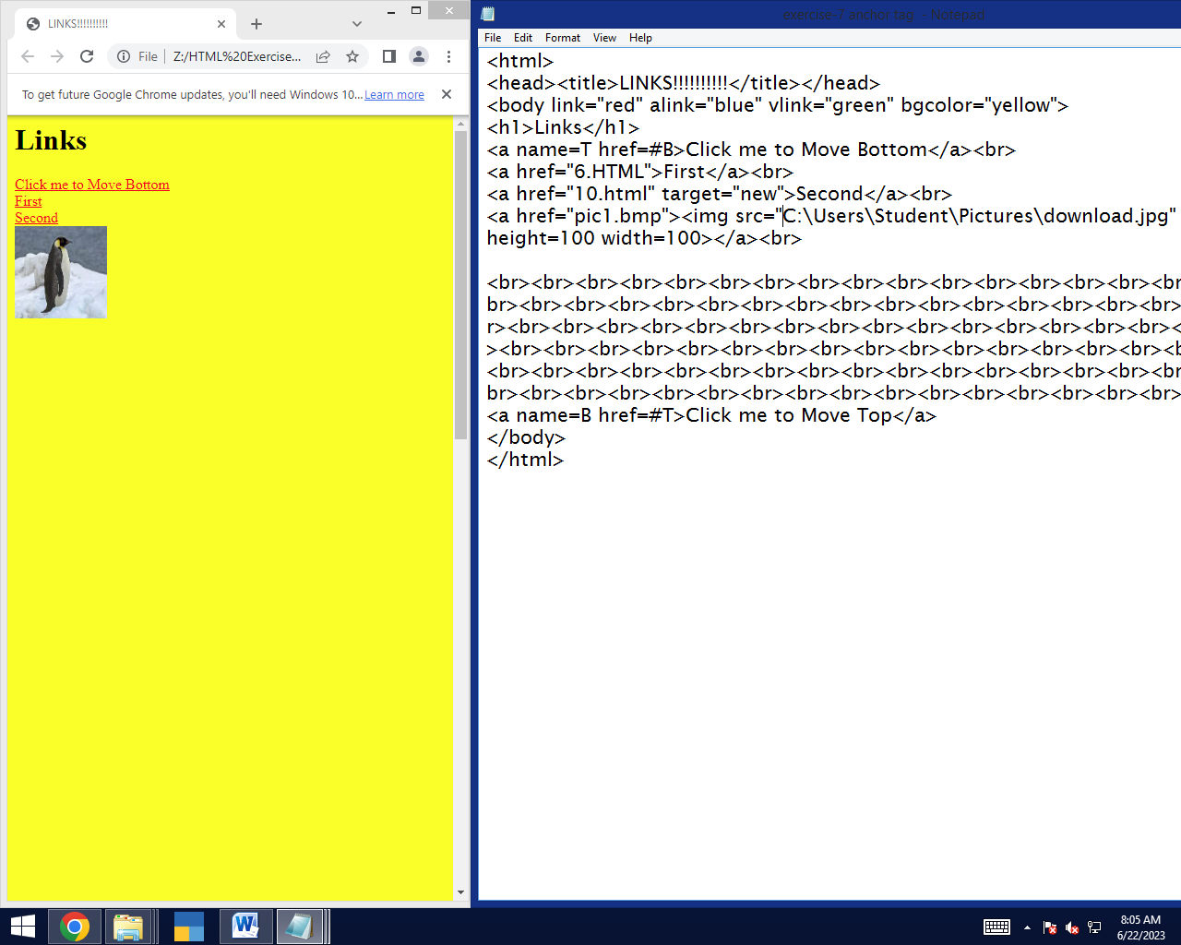

**EX: 8**

**TABLE TAG:**

**OUTPUT:**

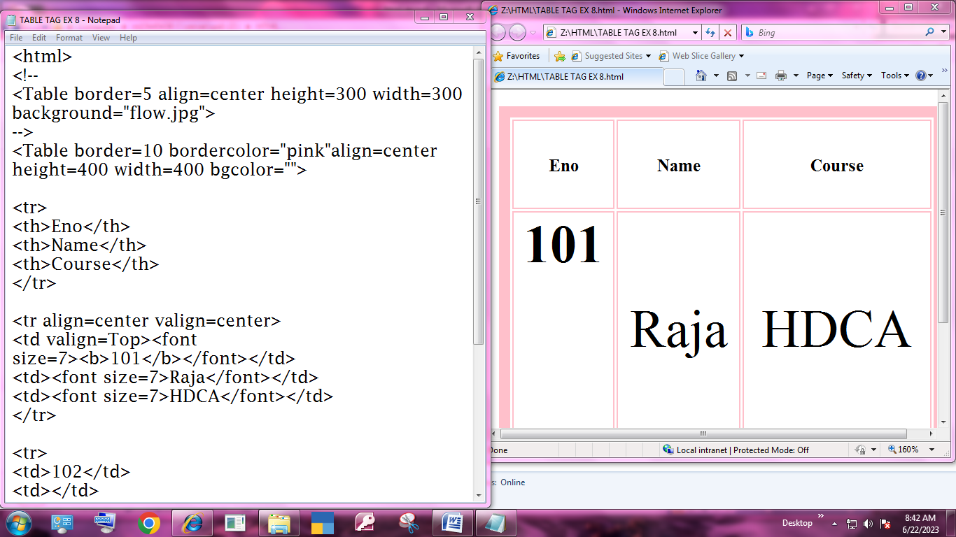

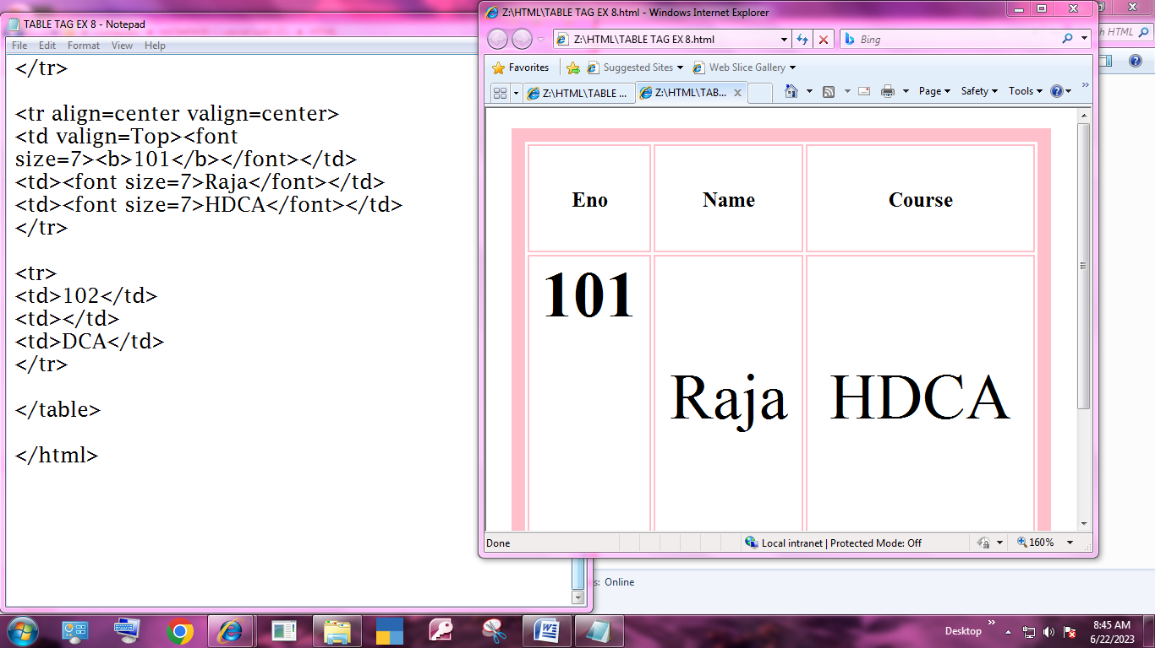

ex: 9

input tag:

output:

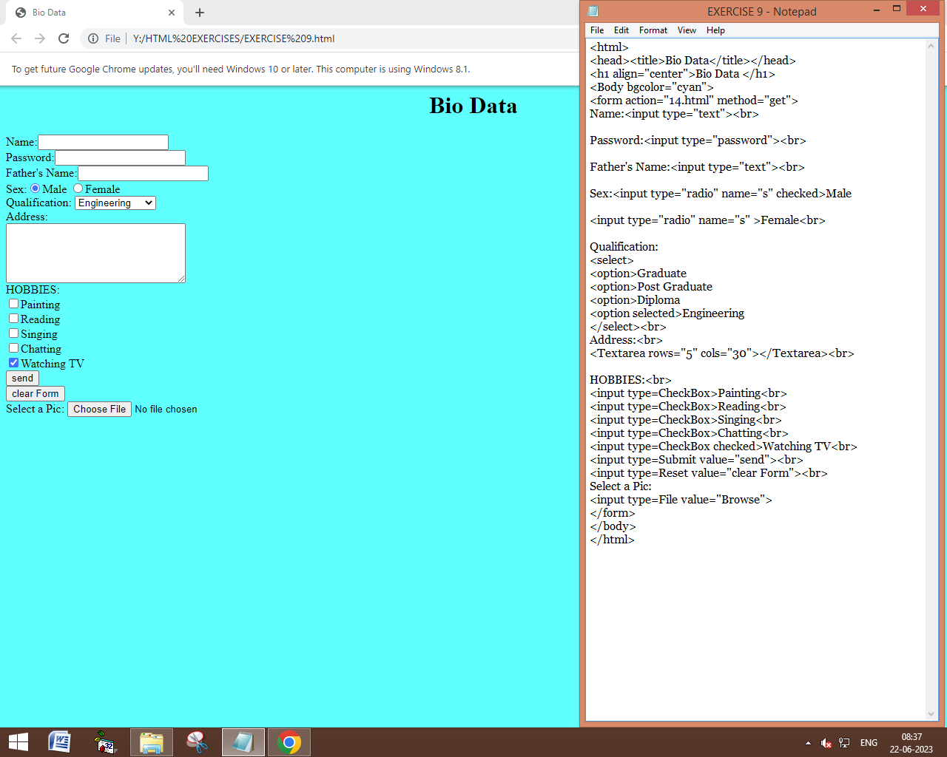

EX : 10

AUIDO TAG:

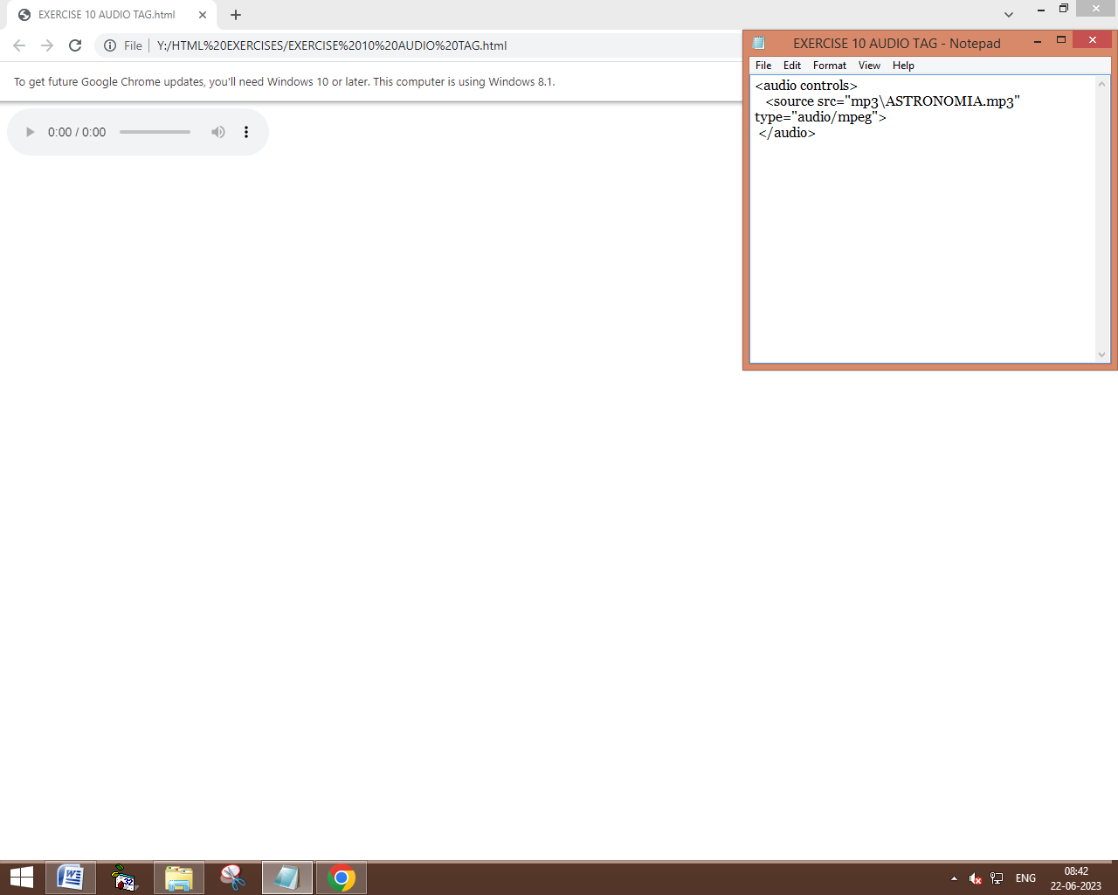

EX: 11

VIDEO TAG:

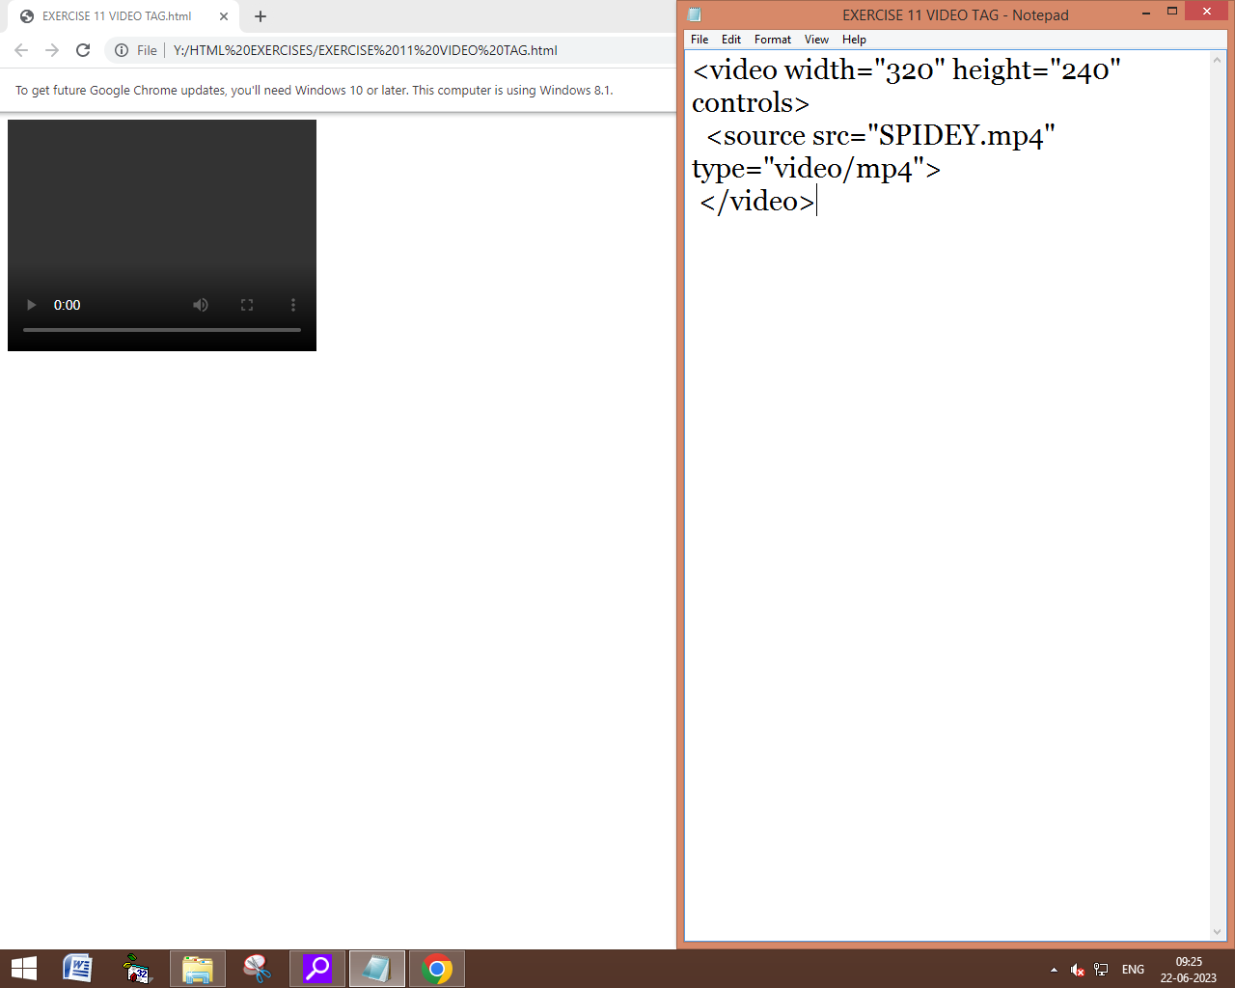

EX: 12

QUOTATION TAG:

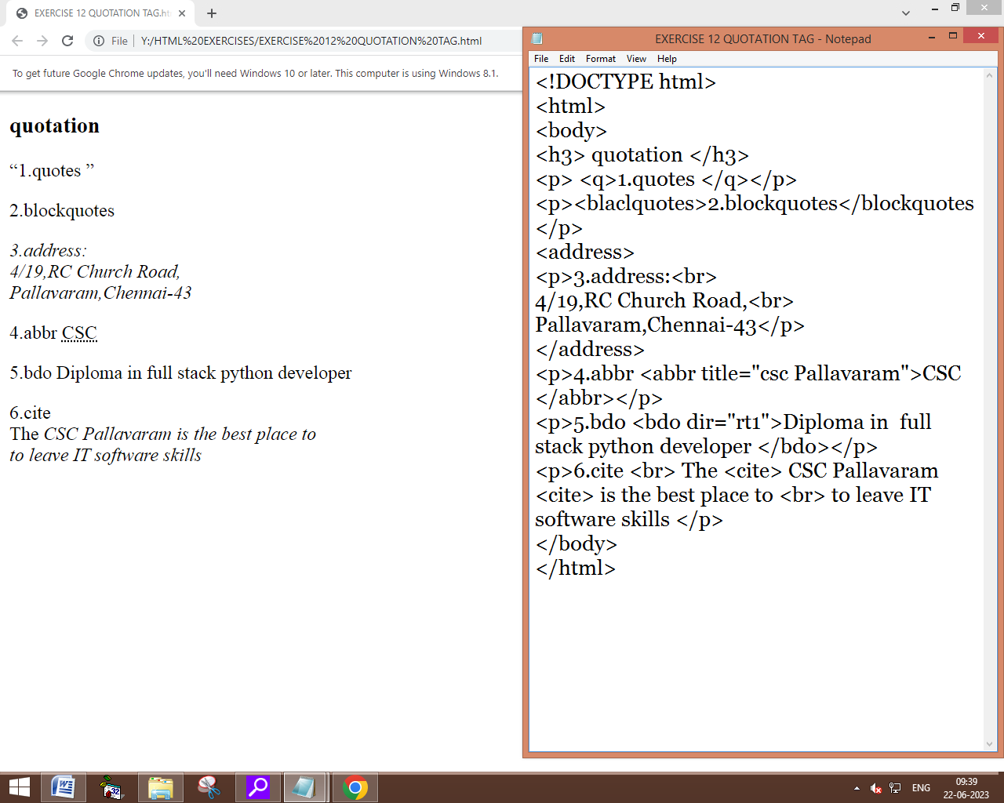

EX: 13

SPELLCHECK:

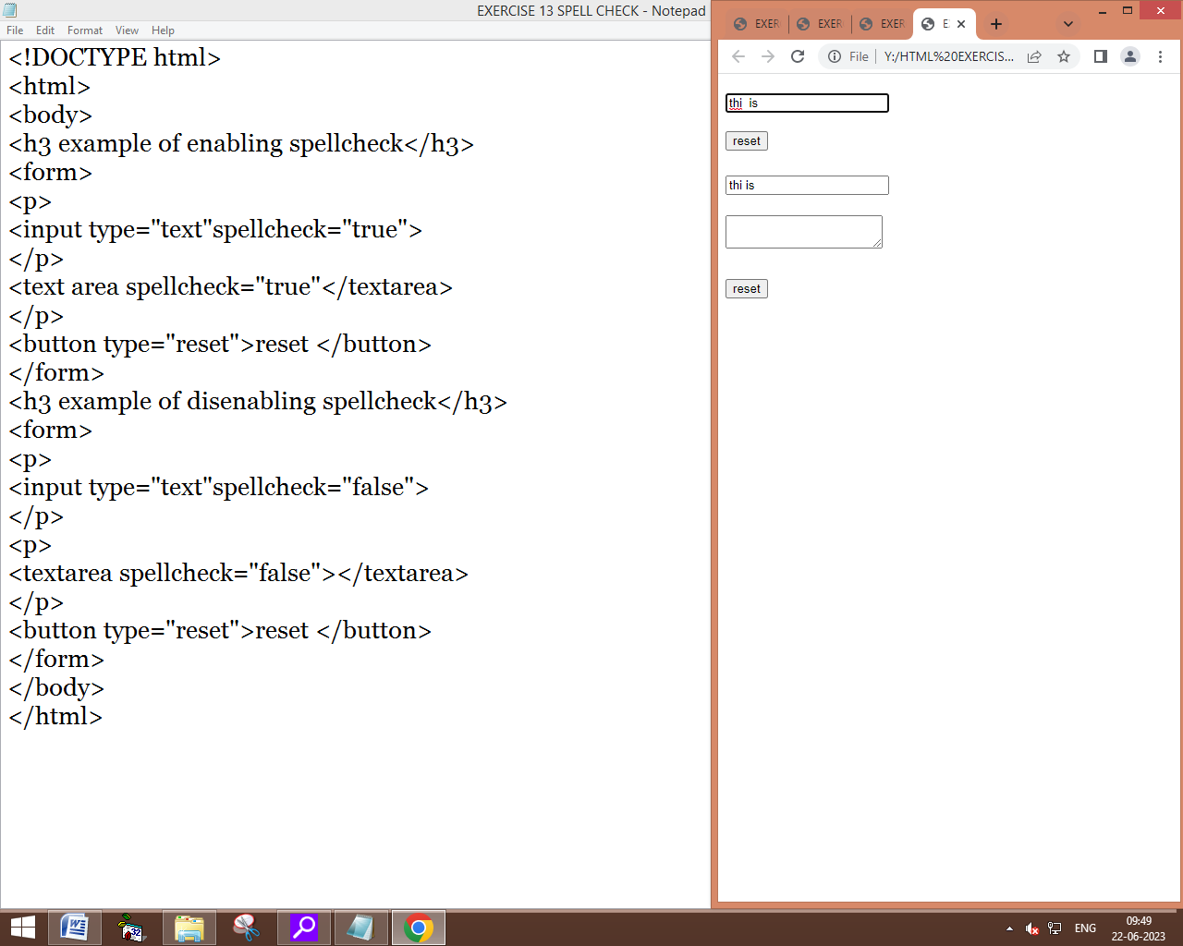

ex: 14

color style and hsl:

output:

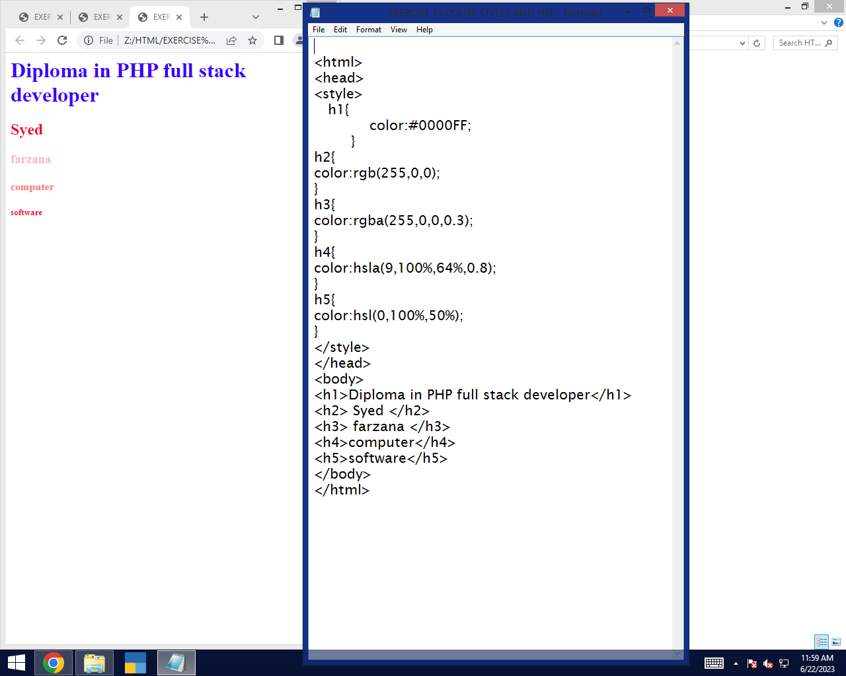

exercise 15:

geo location:

output:

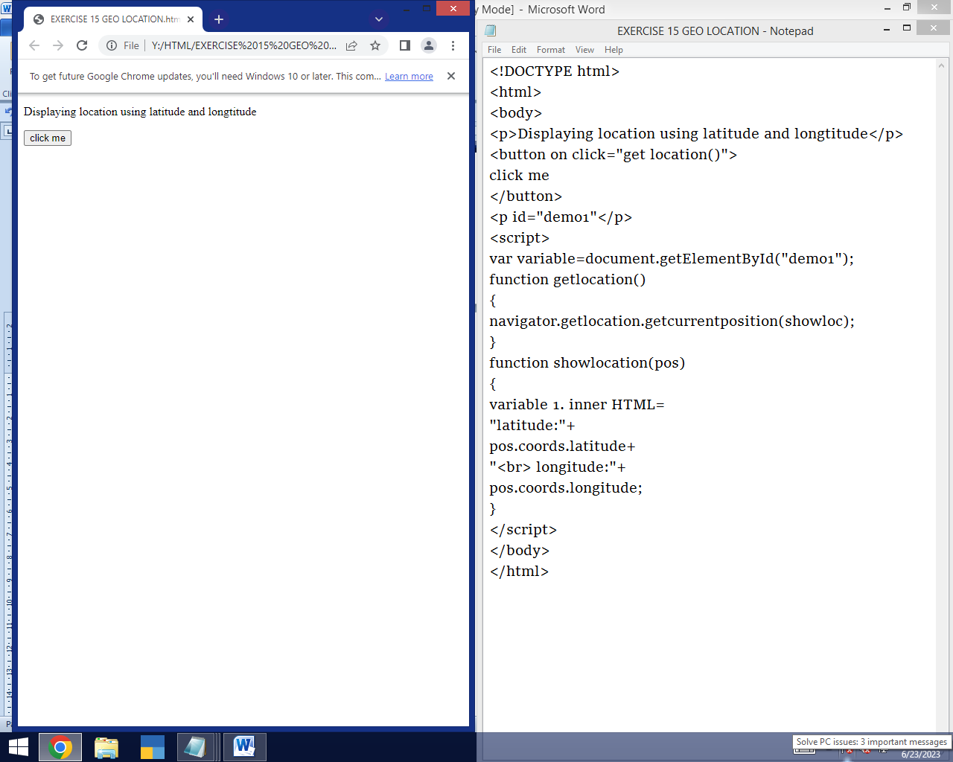

EX 16:

DRAG AND DROP:

OUTPUT:

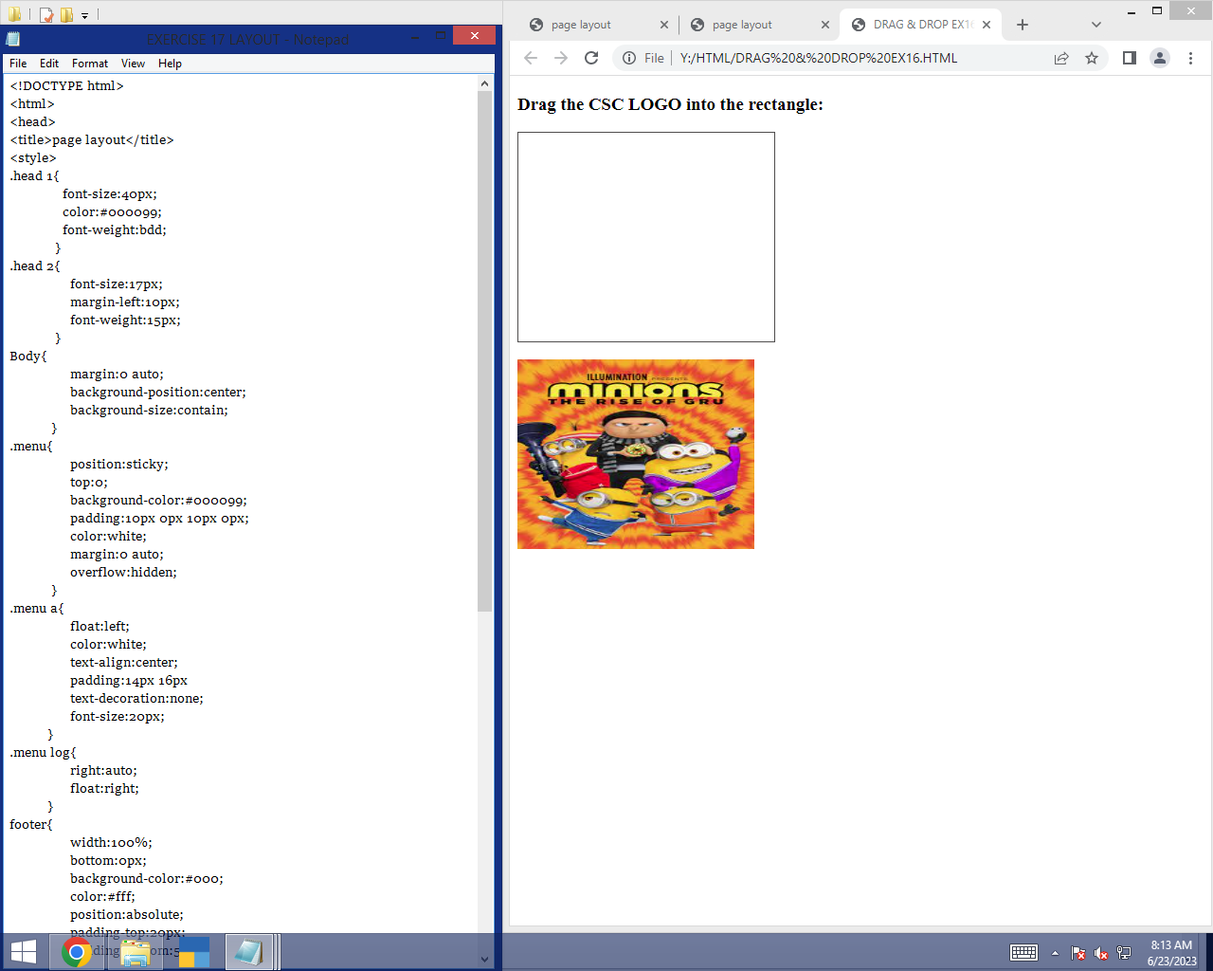

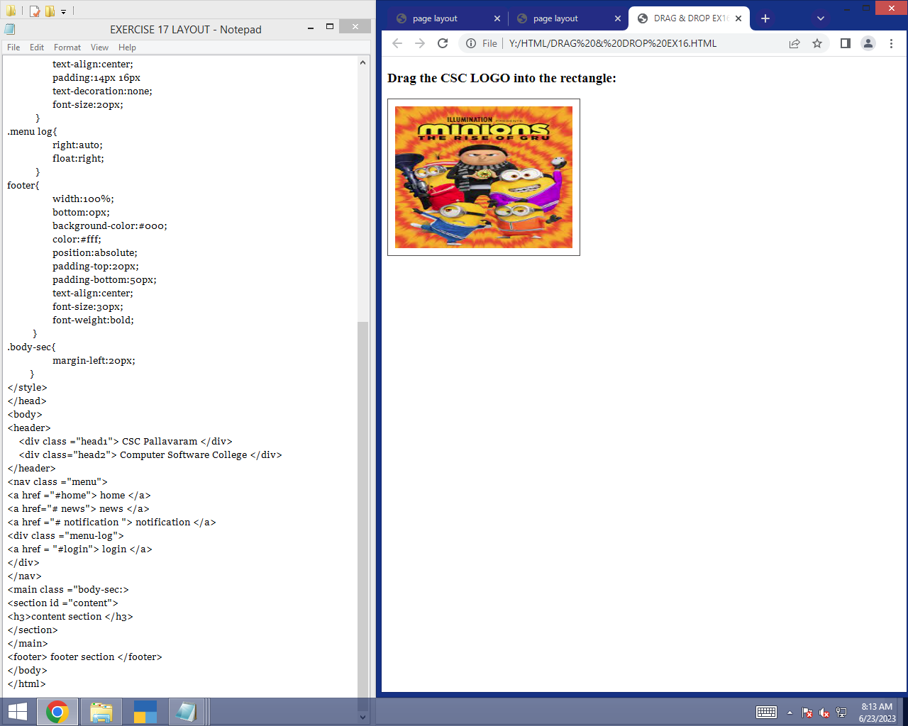

EX: 17

LAYOUT:

OUTPUT:

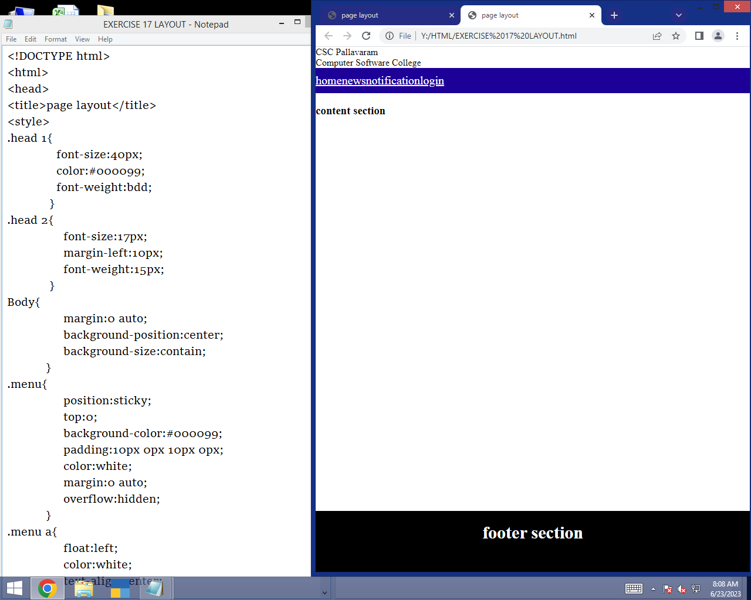

EX 18:

CANVAS:

OUTPUT:

EX 19.1

SHADOW EFFECT:

OUTPUT:

EX 19.2

ROTATE:

OUTPUT:

EX 20:

IMAGE USING CANVAS:

OUTPUT:

